S S S S S S S S

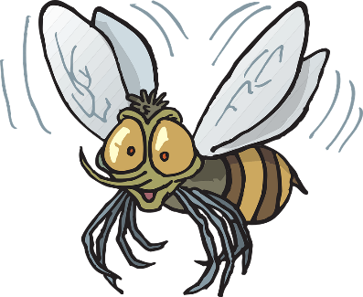

Z Z Z Z Z Z Z Z

Ž Ž Ž Ž Ž Ž Ž Ž

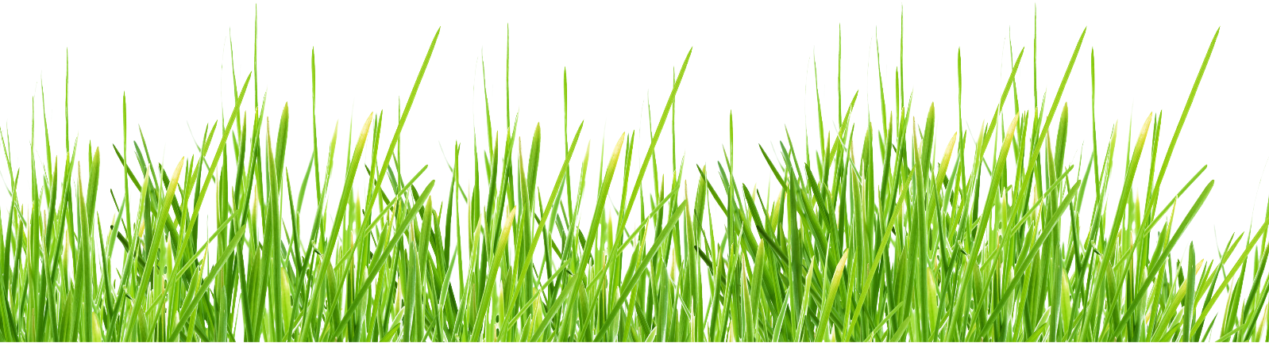

**S**



**Z**

**Ž**

